**WEEK-7 REACT**

* (Superset ID - 6373703) Dipanshu Modi

**Mandatory Hands-on**

**Question 1: Create a React Application named “cricketapp”**

**Scenario:**

**Create cricketapp React app using ES6 features.**

**To achieve this:**

**1. Add ListofPlayers component:**

* **Use map() for 11 players with name & score.**
* **Use arrow function to filter score < 70.**

**2. Add IndianPlayers component:**

* **Use destructuring for odd/even teams.**
* **Merge T20players & RanjiTrophyPlayers using spread.**

**3. Use if-else with flag to show both components on homepage.**

**Code:**

***ListofPlayers.js***

import React from 'react';

function ListofPlayers() {

const players = [

{ name: "Rohit", score: 89 },

{ name: "Kohli", score: 45 },

{ name: "Gill", score: 76 },

{ name: "SKY", score: 50 },

{ name: "Hardik", score: 30 },

{ name: "Rahul", score: 81 },

{ name: "Iyer", score: 66 },

{ name: "Samson", score: 25 },

{ name: "Pant", score: 71 },

{ name: "Bumrah", score: 55 },

{ name: "Shami", score: 90 }

];

const filteredPlayers = players.filter(player => player.score >= 70);

return (

<div>

<h2>List of Players</h2>

<ul>

{players.map((player, index) => (

<li key={index}>{player.name} - {player.score}</li>

))}

</ul>

<h2>List of Players (score ≥ 70)</h2>

<ul>

{filteredPlayers.map((p, index) => (

<li key={index}>{p.name} - {p.score}</li>

))}

</ul>

</div>

);

}

export default ListofPlayers;

***IndianPlayers.js***

import React from 'react';

function IndianPlayers() {

const team = ["Rohit", "Kohli", "Gill", "SKY", "Hardik", "Rahul"];

const oddTeam = team.filter((_, index) => index % 2 === 0);

const evenTeam = team.filter((_, index) => index % 2 !== 0);

const T20players = ["Bumrah", "Shami", "Chahal"];

const RanjiTrophy = ["Pujara", "Rahane"];

const merged = [...T20players, ...RanjiTrophy];

return (

<div>

<h2>Indian Players</h2>

<h3>Odd Team:</h3>

<ul>{oddTeam.map((name, index) => <li key={index}>{name}</li>)}</ul>

<h3>Even Team:</h3>

<ul>{evenTeam.map((name, index) => <li key={index}>{name}</li>)}</ul>

<h3>Merged Team (T20 + Ranji Trophy):</h3>

<ul>{merged.map((name, index) => <li key={index}>{name}</li>)}</ul>

</div>

);

}

export default IndianPlayers;

***App.js***

import React from 'react';

import ListofPlayers from './ListofPlayers';

import IndianPlayers from './IndianPlayers';

function App() {

const flag = true;

return (

<div className="App">

<h1>Cricket App</h1>

{flag ? <ListofPlayers /> : <IndianPlayers />}

</div>

);

}

export default App;

***Output:***

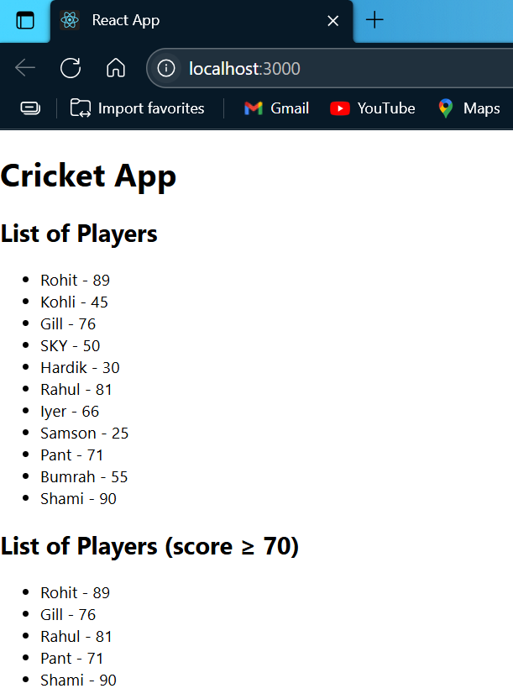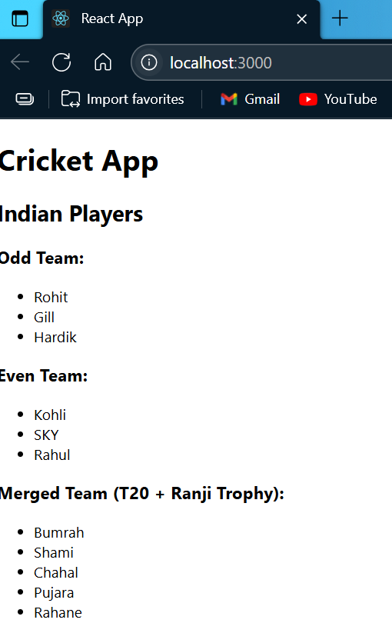

Flag=true

Flag=false

**Question 2: Create a React Application named “officespacerentalapp”**

**Scenario:**

**Create a React Application named “officespacerentalapp” which uses React JSX to create elements, attributes and renders DOM to display the page.**

**To achieve this:**

**1. Create an element to display the heading of the page.**

**2. Attribute to display the image of the office space.**

**3. Create an object of office to display the details like Name, Rent and Address.**

**4. Create a list of Object and loop through the office space item to display more data.**

**5. To apply CSS, Display the color of the Rent in Red if it’s below 60000 and in Green if it’s above 60000.**

***App.js***

import React from 'react';

const offices = [

{

name: "Corporate Hub",

rent: 45000,

address: "Sector 21, New Delhi",

image: "https://images.unsplash.com/39/lIZrwvbeRuuzqOoWJUEn_Photoaday_CSD%20%281%20of%201%29-5.jpg?q=80&w=2070&auto=format&fit=crop&ixlib=rb-4.1.0&ixid=M3wxMjA3fDB8MHxwaG90by1wYWdlfHx8fGVufDB8fHx8fA%3D%3D"

},

{

name: "Urban Workspace",

rent: 75000,

address: "Bandra East, Mumbai",

image: "https://images.unsplash.com/photo-1751151015781-87f5c01e6f1c?q=80&w=1074&auto=format&fit=crop&ixlib=rb-4.1.0&ixid=M3wxMjA3fDB8MHxwaG90by1wYWdlfHx8fGVufDB8fHx8fA%3D%3D"

},

{

name: "Tech Park",

rent: 60000,

address: "Electronic City, Bangalore",

image: "https://images.unsplash.com/photo-1733664602980-5052fc24f9a4?q=80&w=1074&auto=format&fit=crop&ixlib=rb-4.1.0&ixid=M3wxMjA3fDB8MHxwaG90by1wYWdlfHx8fGVufDB8fHx8fA%3D%3D"

}

];

function getRentStyle(rent) {

return {

color: rent >= 60000 ? "green" : "red",

fontWeight: "bold"

};

}

function App() {

return (

<div style={{ padding: '30px', fontFamily: 'Arial' }}>

<h1>Office Space Rentals</h1>

{offices.map((office, index) => (

<div key={index} style={{

border: "1px solid #ccc",

padding: "15px",

margin: "10px 0",

borderRadius: "10px",

backgroundColor: "#f9f9f9"

}}>

<img src={office.image} alt={office.name} width="200" />

<h2>{office.name}</h2>

<p><strong>Address:</strong> {office.address}</p>

<p>

<strong>Rent:</strong> <span style={getRentStyle(office.rent)}>{office.rent}</span>

</p>

</div>

))}

</div>

);

}

export default App;

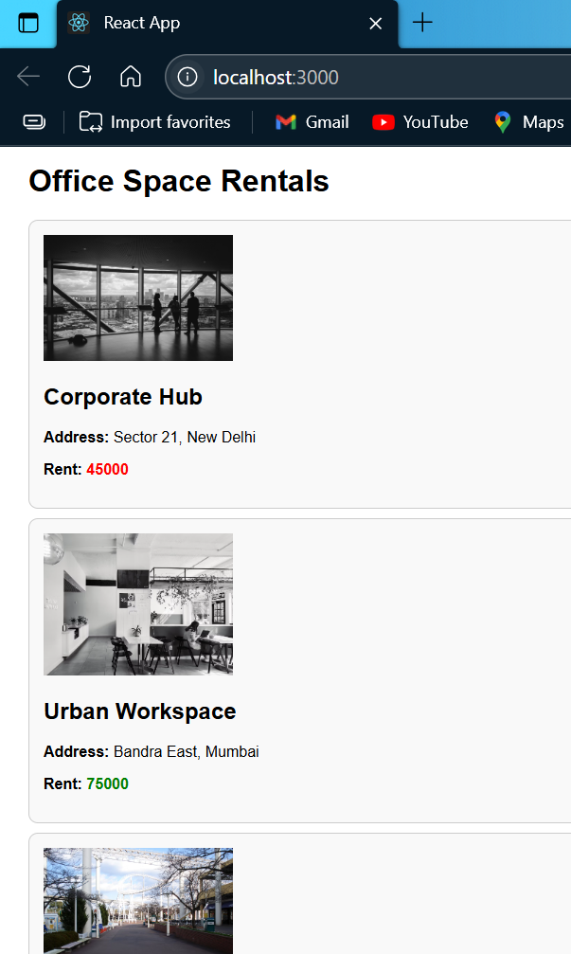

***Output:***

**Question 3: Create a React Application named “eventexamplesapp”**

**Scenario:**

**Create a React Application “eventexamplesapp” to handle various events of the form elements in HTML.**

**To achieve this:**

**1. Add Increment and Decrement buttons:**

* **Increment calls multiple methods: increment counter + show “Hello” message.**
* **Decrement decreases counter value.**

**2. Add Say Welcome button that takes "welcome" as an argument in function**

**3. Add button to handle synthetic event onClick → show “I was clicked”.**

**4. Create CurrencyConvertor component:**

* **Input in INR, on Convert button click, convert to Euro.**
* **Use handleSubmit to perform conversion.**

**Code:**

***Counter.js***

import React, { Component } from "react";

class Counter extends Component {

constructor(props) {

super(props);

this.state = {

count: 0

};

}

increment = () => {

this.setState({ count: this.state.count + 1 });

this.sayHello();

};

decrement = () => {

this.setState({ count: this.state.count - 1 });

};

sayHello = () => {

alert("Hello from Cognizant React Lab!");

};

render() {

return (

<div style={{ marginBottom: "20px" }}>

<h2>Counter: {this.state.count}</h2>

<button onClick={this.increment}>Increment</button>{" "}

<button onClick={this.decrement}>Decrement</button>

</div>

);

}

}

export default Counter;

***Welcome.js***

import React from 'react';

function Welcome() {

const sayWelcome = (msg) => {

alert("Message: " + msg);

};

return (

<div style={{ marginBottom: "20px" }}>

<button onClick={() => sayWelcome("Welcome to React!")}>

Say Welcome

</button>

</div>

);

}

export default Welcome;

### ***ClickMessage.js***

import React from 'react';

function ClickMessage() {

const handleClick = (e) => {

e.preventDefault();

alert("I was clicked");

};

return (

<div style={{ marginBottom: "20px" }}>

<button onClick={handleClick}>Click Me</button>

</div>

);

}

export default ClickMessage;

### ***CurrencyConverter.js***

import React, { useState } from "react";

function CurrencyConverter() {

const [rupees, setRupees] = useState("");

const [euros, setEuros] = useState("");

const handleSubmit = (e) => {

e.preventDefault();

const euro = parseFloat(rupees) * 0.011; // sample conversion rate

setEuros(euro.toFixed(2));

};

return (

<div>

<h2 style={{ padding: '30px', fontFamily: 'Arial' , color:'green'}}>Currency Converter</h2>

<form onSubmit={handleSubmit}>

<label>Rupees: </label>

<input

type="number"

value={rupees}

onChange={(e) => setRupees(e.target.value)}

required

/><br /><br />

<button type="submit">Convert</button>

</form>

{euros && (

<p>

<strong>Euros:</strong> € {euros}

</p>

)}

</div>

);

}

export default CurrencyConverter;

### ***App.js***

import React from "react";

import Counter from "./Counter";

import Welcome from "./Welcome";

import ClickMessage from "./ClickMessage";

import CurrencyConverter from "./CurrencyConverter";

function App() {

return (

<div style={{ padding: "30px", fontFamily: "Arial" }}>

<h1>React Events & Synthetic Event Handling</h1>

<Counter />

<Welcome />

<ClickMessage />

<CurrencyConverter />

</div>

);

}

export default App;

### ***Output:***

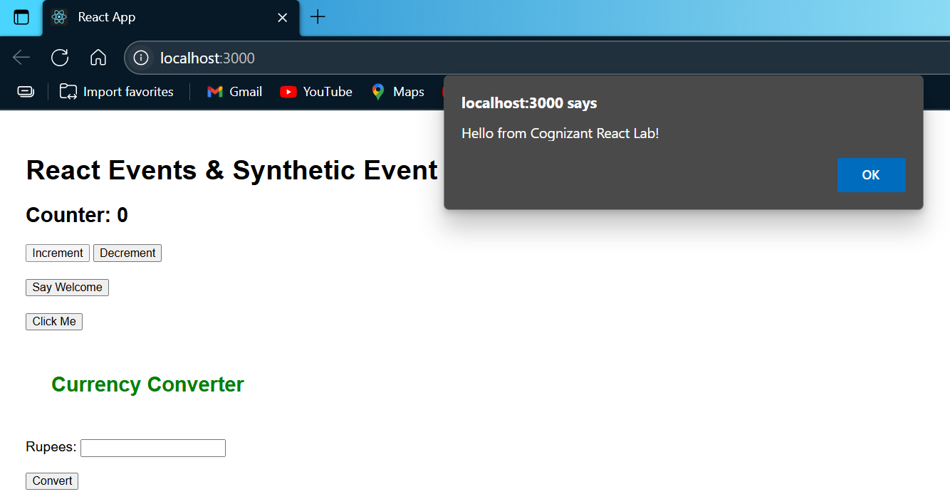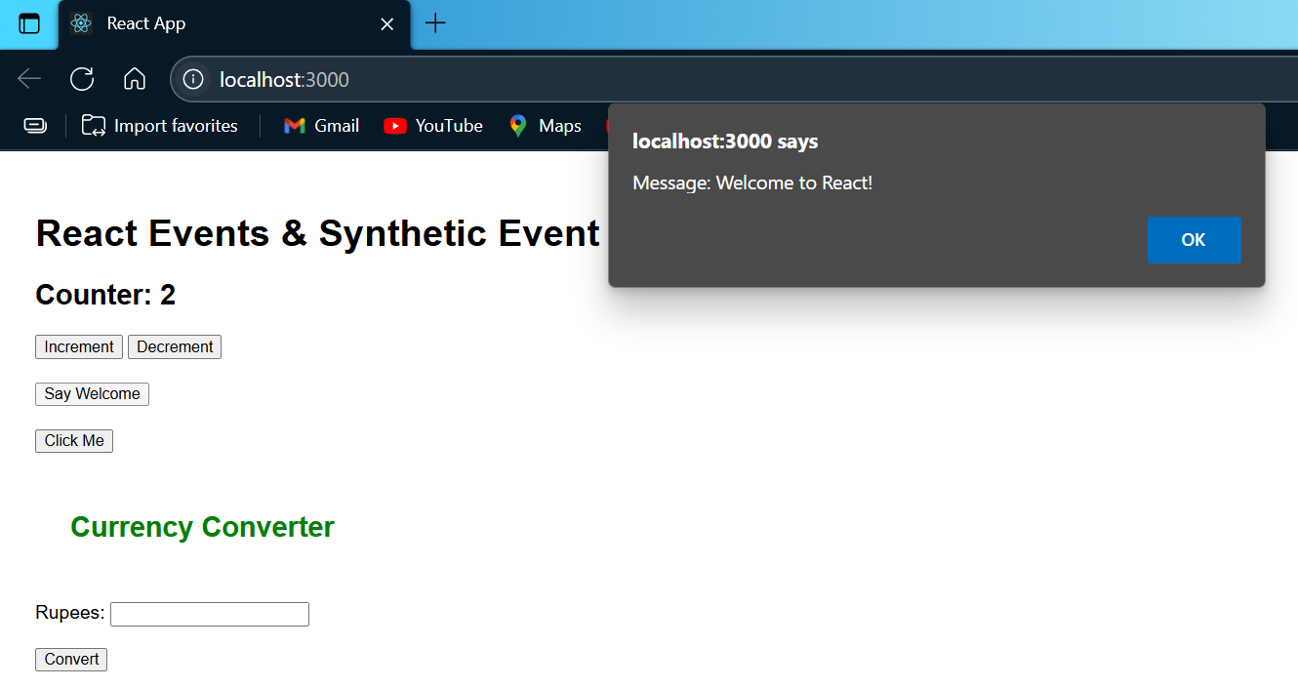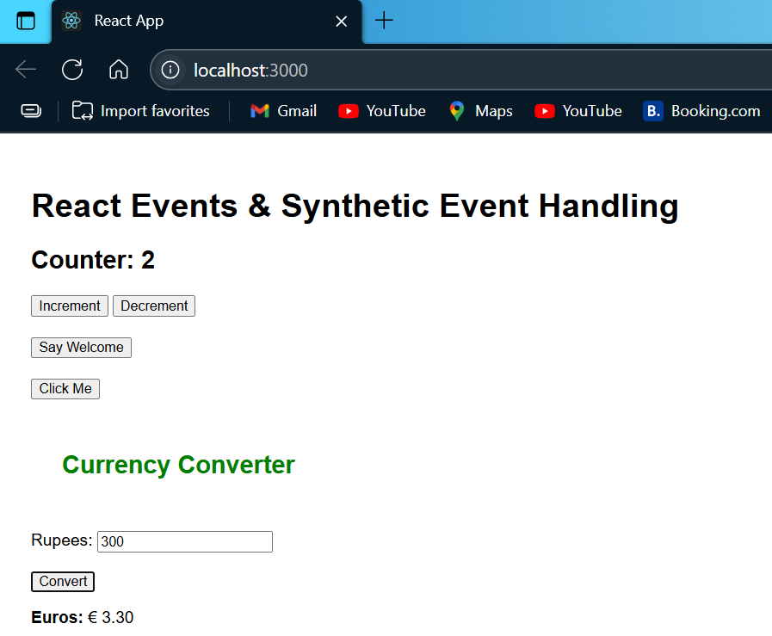



**Question 4: Create a React Application named “ticketbookingapp”**

**Scenario:**

**Create React app ticketbookingapp with conditional views for guest and logged-in users.**

**To achieve this:**

**1. Show Guest Page by default with flight details (no booking access).**

**2. Add Login and Logout buttons.**

**3. On Login, show User Page with ticket booking access.**

**4. On Logout, switch back to Guest Page.**

**5. Use a flag/state to toggle between guest and user views.**

**Code:**

***Guest.js***

import React from "react";

function Guest() {

return (

<div>

<h2>Welcome Guest!</h2>

<p>You can browse flights, but booking requires login.</p>

</div>

);

}

export default Guest;

***User.js***

import React from "react";

function User() {

return (

<div>

<h2>Welcome Back!</h2>

<p>You can now book your tickets.</p>

<button>Book Now</button>

</div>

);

}

export default User;

***LoginControl.js***

import React, { useState } from "react";

import Guest from "./Guest";

import User from "./User";

function LoginControl() {

const [isLoggedIn, setIsLoggedIn] = useState(false);

const handleLogin = () => {

setIsLoggedIn(true);

};

const handleLogout = () => {

setIsLoggedIn(false);

};

let content;

if (isLoggedIn) {

content = <User />;

} else {

content = <Guest />;

}

return (

<div style={{ padding: "20px", fontFamily: "Arial" }}>

<h1>Ticket Booking App</h1>

{isLoggedIn ? (

<button onClick={handleLogout}>Logout</button>

) : (

<button onClick={handleLogin}>Login</button>

)}

<hr />

{content}

</div>

);

}

export default LoginControl;

***App.js***

import React from "react";

import LoginControl from "./LoginControl";

function App() {

return (

<div className="App">

<LoginControl />

</div>

);

}

export default App;

### **Output:**

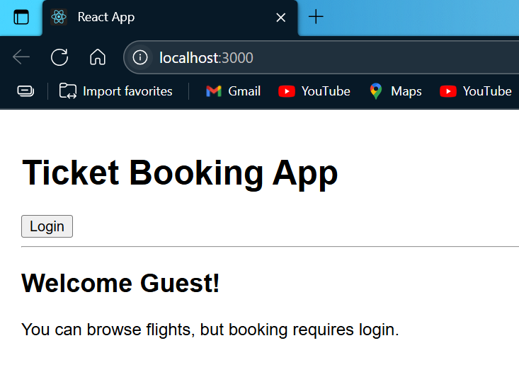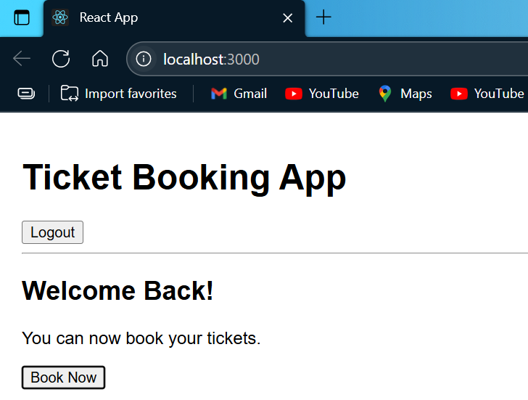

**Question 5: Create a React Application named “bloggerapp”**

**Scenario:**

**Create a React app bloggerapp with 3 components using different conditional rendering methods.**

**To achieve this:**

**1. Create the 3 components in src.**

**2. In App.js, implement multiple conditional rendering techniques.**

**3. Use flags or state variables to switch between components.**

**4. Render the components based on conditions.**

**Code:**

***BlogDetails.js***

import React from "react";

function BlogDetails({ blogs }) {

return (

<div>

<h2>Blog List</h2>

{blogs.length > 0 ? (

blogs.map((blog, index) => (

<div key={index}>

<h4>{blog.title}</h4>

<p>{blog.description}</p>

<hr />

</div>

))

) : (

<p>No blogs found.</p>

)}

</div>

);

}

export default BlogDetails;

***BookDetails.js***

import React from "react";

function BookDetails({ books }) {

return (

<div>

<h2>Book List</h2>

<ul>

{books.map((book, index) => (

<li key={index}>

<strong>{book.title}</strong> by {book.author}

</li>

))}

</ul>

</div>

);

}

export default BookDetails;

### ***CourseDetails.js***

import React from "react";

function CourseDetails({ courses }) {

return (

<div>

<h2>Courses Offered</h2>

<ul>

{courses.map((course, index) => (

<li key={index}>{course.name} – {course.duration}</li>

))}

</ul>

</div>

);

}

export default CourseDetails;

### ***App.js***

import React, { useState } from "react";

import BookDetails from "./BookDetails";

import BlogDetails from "./BlogDetails";

import CourseDetails from "./CourseDetails";

function App() {

const [view, setView] = useState("books");

const books = [

{ title: "Atomic Habits", author: "James Clear" },

{ title: "Deep Work", author: "Cal Newport" }

];

const blogs = [

{ title: "React Tips", description: "Learn about React best practices" },

{ title: "Frontend Trends", description: "What's new in frontend?" }

];

const courses = [

{ name: "ReactJS", duration: "30 hours" },

{ name: "NodeJS", duration: "25 hours" }

];

return (

<div style={{ padding: "30px", fontFamily: "Arial" }}>

<h1>BloggerApp - Conditional Rendering</h1>

<div style={{ marginBottom: "20px" }}>

<button onClick={() => setView("books")}>Show Books</button>{" "}

<button onClick={() => setView("blogs")}>Show Blogs</button>{" "}

<button onClick={() => setView("courses")}>Show Courses</button>

</div>

{view === "books" && <BookDetails books={books} />}

{view === "blogs" && <BlogDetails blogs={blogs} />}

{view === "courses" && <CourseDetails courses={courses} />}

</div>

);

}

export default App;

### **Output:**

Name – Dipanshu Modi

Roll Number – 2205032

Superset ID - 6373703

College – Kalinga Institute of Industrial Technology (KIIT), Bhubaneswar